**UX design**

Student: Jorn Kersten

Student number: 483331

Date: 05-09-2022

Semester: S-DB-IPS3-S3-DB03

Inhoud

What is UX design 3

Research 3

Step one user research 4

Interview 4

Survey 4

Step two creating a simple design 4

Storyboard 4

Step three creating wireframes 4

Digital wireframes 4

Paper wireframes 4

Step four creating a prototype 5

Step five testing 5

Usability testing 5

A/B testing 5

Step six implementing 5

My target audience 6

Simple design 6

Wireframes 7

Prototype 9

Testing 10

Implementing 11

# What is UX design

UX design stands for user experience design. The goal in creating a UX design is for a user to be able to get anywhere on the website easily and have a clear overview of what they can do on the website. It is also important that the user has a pleasant experience with the website, for this it is important that it all looks neat too.

# Research

The UX process and the methodology behind it consists of five small steps.

The first step is user research, where you want to find out who you are making the website for. The second step is to create a simple design based on the data obtained from step one. After this, the design is transformed from paper into a tighter design with wireframes. A wireframe is a very simple sketch with straight lines, often digital, that does not include any images or colours. A small prototype is then created in colour for the user to click through. This is needed for the next step, which is testing. In testing, the prototype is given to a user and a few questions are asked. The user then has to navigate himself to, for example, a certain place, after this the user indicates what he thought of it and what went well and what did not. If everything went well, the design is implemented and finally put online. This is done by programmers. This is repeated for all pages of the website until the design is finished.

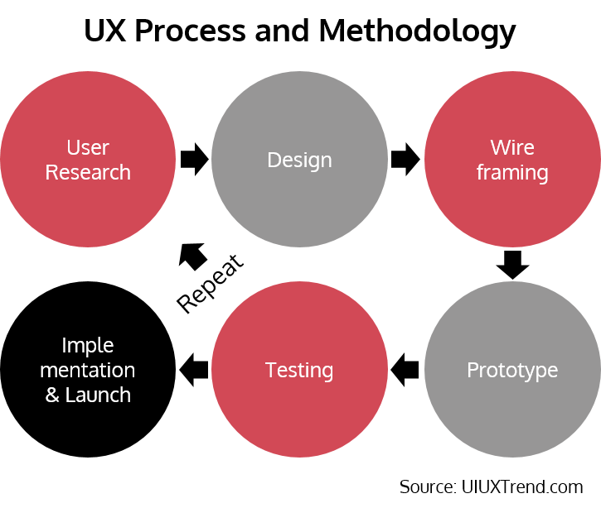

## Step one user research

Before you can start creating a design you want to know who you are creating the website for. This will then make it clearer what is needed to create a clear design.

### Interview

There are a number of different ways to get to this you can interview users. With an interview you have a guided conversation where the researchers ask questions and take down the responses from the participants. The advantage of interview lies in its flexibility and a well-structured interview enables researchers to gain detailed information and deep insights into the users.

### Survey

This is another common method of research. This method of research is often done to obtain a large amount of data. It can be done online or on paper, but it is often difficult to ask the right amount of questions.

## Step two creating a simple design

Users may think of the appearance of a website or product when we talk about design. They will describe it as pretty or not pretty.

After gaining more understanding of your users from research, you can first create a set of personas, storyboards, user journey map and ecosystem map.

### Storyboard

One way to capture this is through a storyboard. A storyboard is a series of small sketches that give stakeholders and researchers an idea of what the website will look like. They can then brainstorm together to come up with an idea, using the data obtained from the user research.

## Step three creating wireframes

A wireframe is a visual guide to a project. In a wireframe, it is easy to clarify what the structure of a page should be, what the navigation structure of the website should be and what the interface should look like. An important part of a wireframe is that it is very simple, there is no formatting involved yet in terms of colours and images. However, it does indicate the locations of images.

### Digital wireframes

Wireframes can be created in a number of ways. There are online websites that make it very simple, there are also all kinds of programmes you can download to make it easier. When making wireframes, a basic outline of what the project will roughly look like quickly becomes clear. An advantage of it being digital is that adjustments can be made very easily.

### Paper wireframes

Paper wireframes are often created with the stakeholder so that, at the first meeting, they get an idea of how the website can be made. This is usually still worked out in a digital form to make any adjustments easier.

## Step four creating a prototype

A prototype is the closest thing to the real product. This is what the real product is based on; it may differ slightly from the design. In this step, final problems can also be taken out of the design.

These may include illogical navigation, no good or clear overview, etc.

## Step five testing

After creating a prototype comes testing. This is where testing is done with users to find out if the prototype works as intended. Users are asked to do something and share their experiences so that these can be incorporated.

### Usability testing

In usability testing, participants are invited to perform a few guided tasks at the prototype and actual product. The settings are usually in the lab or in the form of contextual inquiry. Contextual inquiry is a semi-structured interview method to obtain information about the context of use. Users are observed and questioned while they work in their own environments to make them feel comfortable.

Usability testing might be one of the most used UX methods. It is very effective in identifying potential usability or design issues and explore the area of improvement in functionality.

### A/B testing

A/B testing involves using two versions of the prototype to see which one has better results. This is usually used when implementing a new functionality within the website.

## Step six implementing

After user testing, the validated prototype can finally be turned into a real product before it is officially launched.

However, the role of a UX researcher does not end here. Research activities should continue to monitor the user experience of the website or product through appropriate key performance indicators (KPI) or metrics. But also for identifying the area of improvements through user testing.

**Source:** <https://uiuxtrend.com/user-experience-ux-process/>

# My target audience

I want to create a comparison website. It should be suitable for young and older people. Everyone should be able to easily handle the website and understand its purpose.

Adding products to a shopping list should be easy to find and simple to do. The shopping list should consist of one supermarket not different products from different supermarkets. The buttons for navigating should further be clear with an icon and possibly text next to it.

# Simple design

**Op papier korte schetsjes maken over het product, kleine onderdelen laten zien met afbeeldingen en dan kort vertellen.**

# Wireframes

I worked out my wireframes based on the simple design. To this, I added a structure of my web pages and incorporated the navigation structure. I showed this to some potential users and asked if they saw any special things on the wireframes.

This is the homepage, here all products are displayed. The overall view shows all products and at what supermarket they are the cheapest at. When opening a product, all products are shown so the user can choose from which supermarket the want to add a product to the shopping list.

This shows the shopping list page, on this page the shopping list of the user is shown. Here all products are shown, a user can choose if they want to increase the amount of a certain product they need. They can also remove the item from the shopping list, or swap to a different supermarket.

# Prototype

In this step, I recreated my wireframes and added clear colours to make the website look neat. I then added the navigation structure and added any missed features to the pages.

The image above shows the homepage, this is also the first wireframe shown in the previous step.

The image above shows the navigation structure. Here you can see the connections between the pages, and how to get to a particular page.

# Testing

In testing, I asked some younger and one older user to complete some steps and share their findings of it with me.

For testing, I started by asking some random users to navigate to the login page.

Findings:

User 1 (... years old):

User 2 (... years old):

User 3 (... years old):

I then asked if they could navigate to the page where products can be added to the shopping list.

Findings:

User 1 (... years old):

User 2 (... years old):

User 3 (... year old):

Finally, I asked if they could navigate to the page where these products are displayed.

Findings:

User 1 (... years old):

User 2 (... years old):

User 3 (... years old):

# Implementing

After adding/adjusting user feedback in testing, I started implementing. I recreated the pages with bootstrap and css. I always showed these to some users after adding them and asked if the pages were clear as a control check.